Hi Jane,

I have inserted your ERD, because it is important that despite it not being relational, you still fall back to the same logic. I am going to answer your questions here because I will be referring back to this ERD

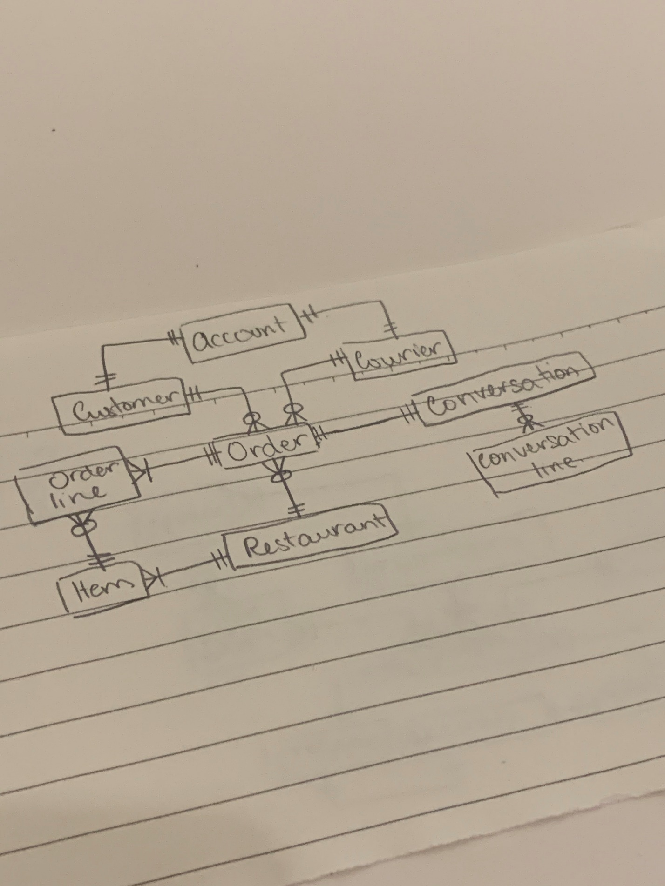

1. **Account:** I would get rid of customer and courier tables and just keep Account. And just have a field in account called type. Each record could store whatever information you wanted to include. But in OOP you could do inheritance from account. But your solution would also work.   
   There would also be **no need for a sub map for account** (My solution or your solution) (If this makes sense) and this would get rid of complexity in the other tables which refers to account, like order.
2. **Duplicate data – what to store:** remember you only need to store information that the user would need to see at a glance, not details in the duplicated data. I see you get this, as you have stored less but I feel that restaurant in order is too much as all you need is the name. I do not care anymore now that order is placed and is on route about more information.
3. **Conversation:** Yes, conversation is a tricky one, but it could be made simple (At least in design and on database side) and literally just have a single string to store full conversation, and the format of the string could follow a convention of:

**[Author-Time]** Message <Newline character>

[Author-Time] Message

1. **Item (Order)**: Remember we are not dealing with details of the order, that is a separate part of the system. So again potentially I would keep just a single String like conversation in a certain format to have item details, but it is not required because order is a separate system and we are basically taking what exists and this could be done as a simple formatted string..

I hope this answers all your questions, shout if any other questions.

|  |  |  |
| --- | --- | --- |
| account | customer | courier |
| {  “id’: int,  “email”: String,  “password”: String,  “first_name”: String,  “last_name”: String,  “phone_no”: String,  “status”: String  } | {  “id’: int,  “street_address”: String,  “zipcode”: VARCHAR,  “city”: VARCHAR (30),  “account”: [  {  “id”: String,  “first_name”: String,  “phone_no”: String  “status”: String  } ]  } | {  “id’: int,  “license_plate”: String,  “license_no”: String,  “account”: [  {  “id”: String,  “first_name”: String,  “phone_no”: String  “status”: String  } ]  } |

|  |  |  |
| --- | --- | --- |
| order | restaurant | ~~conversation~~ |
| {  “id’: int,  “time_create”: DATETIME,  “status”: String,  “deliver_time”: DATETIME,  “actual_deliver”: DATETIME,  “customer”: [  {  “id”: String,  “street_adress”: String,  “zipcode”: VARCHAR,  “city”: VARCHAR(30),  “account”: [  {  “first_name”: String,  “phone_no”: String  “status”: String  } ]  } ],  “courier”: [  {  “id”: String,  “account”: [  {  “first_name”: String,  “phone_no”: String  “status”: String  }]  }],  “restaurant”: [  {  “id”: String,  “name”: String,  “item”: [  {  “id”: String,  “name”: String,  “price”: double  }]  }],  } | {  “id’: int,  “name”: String,  “cuisine”: String,  “phone_no”: String,  “street_address”: String,  “zipcode”: VARCHAR,  “city”: VARCHAR (30),  “rating”: float,  “item”: [  {  “id”: String,  “name”: String  “description”: String,  “price”: double  }]  } | ~~{~~  ~~“id’: int,~~  ~~“message”: [~~  ~~{~~  ~~“time”: DATETIME,~~  ~~“sender”: [~~  ~~{~~    ~~}]~~  ~~}]~~  ~~}~~ |